Looma Motherboard Revision 2.3

2014-7-8

Product Requirements

Input:

12V DC power in, capable of up to 10A

Odroid fan control signal (5V)

Line Audio (Odroid)

Output:

12V pass-through (fan)

5V buck conversion (Odroid power)

19.5V boost conversion (projector, requirement: 3A)

Amplified audio (speakers)

Debug out (each voltage and ground for test chip)

I/O Data:

Ethernet pass-through

USB (7-port hub)

Circuit Protection:

Shutoff when input voltage falls below 11V

Shutoff when input voltage exceeds 13V

Eliminates surges, spikes and transients

Future Enhancements:

Input voltage monitoring/logging

New, less expensive power connector

Temperature monitoring for auto shutdown

Soft on/off switch

Theory of Operation

12V input through IRF7815PBF which…

Feeds to protection circuit, LTC 4364 which …..

“The LTC4364 surge stopper with ideal diode controller protects loads from high voltage transients. It limits and regulates the output during an overvoltage event, such as load dump in automobiles, by controlling the voltage drop across an external N-channel MOSFET pass device. The LTC4364 also includes a timed, current limited circuit breaker. In a fault condition, an adjustable fault timer must expire before the pass device is turned off. The LTC4364-1 latches off the pass device while the LTC4364-2 automatically restarts after a delay. The LTC4364 precisely monitors the input supply for overvoltage (OV) and undervoltage (UV) conditions. The external MOSFET is held off in undervoltage and auto-retry is disabled in overvoltage.

An integrated ideal diode controller drives a second MOSFET to replace a Schottky diode for reverse input protection and output voltage holdup. The LTC4364 controls the forward voltage drop across the MOSFET and minimizes reverse current transients upon power source failure, brownout or input short.”

5V buck conversion done by AP1501A, which ….

“The AP1501A series are monolithic ICs that are designed for a step-down DC/DC converter, and possess the ability to drive a 5A load without additional transistor component. The external shutdown function can be controlled by logic level and then come into standby mode. The internal compensation makes feedback control have good line and load regulation without external design. Regarding protected function, thermal shutdown is to prevent over temperature operating from damage, and current limit is against over current operating of the output switch. The AP1501A series operates at a switching frequency of 150Khz thus allowing smaller sized filter components than what would be needed with lower frequency switching regulators. Other features include a guaranteed +4% tolerance on output voltage under specified input voltage and output load conditions, and +15% on the oscillator frequency.

The output version includes fixed 3.3V, 5V, 12V, and an adjustable type.”

19.5V boost conversion is done with LT3844 switching regulator IC,

“The LT3844 is a DC/DC controller used for medium power, low part count, high efficiency supplies. It offers a wide 4V to 60V input range (7.5 minimum start-up voltage) and can implement step-down, step- up, inverting and SEPIC topologies.

The LT3844 includes Burst Mode operation, which reduces quiescent current below 120uA and maintains high efficiency at light loads. An internal high voltage bias regulator allows for simple biasing.

Additional features include current mode control for fast line and load transient response; programmable fixed operating frequency that can be synchronized to an external clock for noise sensitive applications; a gate driver capable of driving N-channel MOSFETs; a precision undervoltage lockout function; 10uA shutdown current; short-circuit protection and a programmable soft-start function.”

3.3V Buck by LT1963-3.3 which…

“The LT®1963 series are low dropout regulators optimized for fast transient response. The devices are capable of supplying 1.5A of output current with a dropout voltage of 340mV. Operating quiescent current is 1mA, dropping to <1µA in shutdown. Quiescent current is well controlled; it does not rise in dropout as it does with many other regulators. In addition to fast transient response, the LT1963 regulators have very low output noise which makes them ideal for sensitive RF supply applications. Output voltage range is from 1.21V to 20V. The LT1963 regulators are stable with output capacitors as low as 10µF. Internal protection circuitry includes reverse battery protection, current limiting, thermal limiting and reverse current protection. The devices are available in fixed output voltages of 1.5V, 1.8V, 2.5V, 3.3V and as an adjustable device with a 1.21V reference voltage. The LT1963 regulators are available in 5-lead TO-220, DD, 3-lead SOT-223, 8-lead SO, and Exposed Pad 16-lead TSSOP packages.”

USB Hub Control by TUSB2077A which…

“The TUSB2077A hub is a 3.3-V CMOS device that provides up to seven downstream ports in compliance with the USB 2.0 specification. Because this device is implemented with a digital state machine instead of a microcontroller, no software programming is required. Fully-compliant USB transceivers are integrated into the ASIC for all upstream and downstream ports. The downstream ports support both full-speed and low-speed devices by automatically setting the slew rate according to the speed of the device attached to the ports. The configuration of the BUSPWR terminal selects either the bus-powered or self-powered mode. The introduction of the DP0 pullup resistor disable terminal, DP0PUR, makes it much easier to implement an onboard bus/self- power dynamic-switching circuitry. The three LED indicator control output terminals also enable the implementation of visualized status monitoring of the hub and its downstream ports. With these new function terminals, the end equipment vendor can considerably reduce the total board cost while adding additional product value.”

USB Port Power Regulation By 2x TPS2054 which…

“The TPS2044 and TPS2054 quad power- distribution switches are intended for applications where heavy capacitive loads and short circuits are likely to be encountered. The TPS2044 and the TPS2054 incorporate in single packages four 135-mΩ N-channel MOSFET high-side power switches for power-distribution systems that require multiple power switches. Each switch is controlled by a logic enable that is compatible with 5-V logic and 3-V logic. Gate drive is provided by an internal charge pump that controls the power-switch rise times and fall times to minimize current surges during switching. The charge pump, requiring no external components, allows operation from supplies as low as 2.7 V.

When the output load exceeds the current-limit threshold or a short is present, the TPS2044 and TPS2054 limit the output current to a safe level by switching into a constant-current mode, pulling the overcurrent (OCx) logic output low. When continuous heavy overloads and short circuits increase the power dissipation in the switch causing the junction temperature to rise, a thermal protection circuit shuts off the switch to prevent damage. Recovery from a thermal shutdown is automatic once the device has cooled sufficiently. Internal circuitry ensures the switch remains off until valid input voltage is present.”

Audio Amplification By TPA1517 which…

“The TPA1517 is a stereo audio power amplifier that contains two identical amplifiers capable of delivering 6 W per channel of continuous average power into a 4-Ω load at 10% THD+N or 5 W per channel at 1% THD+N. The gain of each channel is fixed at 20 dB. The amplifier features a mute/standby function for power-sensitive applications. The amplifier is available in the PowerPAD™ 20-pin surface- mount thermally-enhanced package (DWP) that reduces board space and facilitates automated assembly while maintaining exceptional thermal characteristics. It is also available in the 20-pin thermally enhanced DIP package (NE).”

MOSFETS FDS6630A, FDB33N25, and FDB3682 are used by buck/boost controllers and for fan control.

Documentation

The design documents and CAD files are in Dropbox. The schematic, board design and bill of materials were generated with DesignSpark PCB. Fabrication courtesy of OSH Park. Soldering (tentatively) by Wolff.

Bill of Materials

|  |  |  |  |  |
| --- | --- | --- | --- | --- |
| Ref Name | Value | Manufacturer | MPN | Digikey Part Number |
| U10 |  | Fairchild Semiconductor | 1N4148 | 1N4148TACT-ND |
| C9 | 0.1uF | ON Semiconductor | 1N5373BRLG | 1N5373BGOS-ND |
| U4 |  | Molex | 22-04-1021 | WM18785-ND |
| U15 |  | Molex | 22-04-1041 | WM18787-ND |
| U16 |  | Molex | 22-03-2041 | WM4002-ND |
| U27 |  | Molex | 22-04-1021 | WM18785-ND |
| U17 |  | Molex | 22-04-1031 | WM18786-ND |
| U23 | 18pF | AVX | 06035A180JAT2A | 478-1166-1-ND |
| U24 | 18pF | AVX | 06035A180JAT2A | 478-1166-1-ND |
| C6 | 100u | AVX | GRM31CR60J107ME39L | 490-4539-1-ND |
| C14 | 100u | AVX | GRM31CR60J107ME39L | 490-4539-1-ND |
| C20 | 100u | AVX | GRM31CR60J107ME39L | 490-4539-1-ND |
| C21 | 100u | AVX | GRM31CR60J107ME39L | 490-4539-1-ND |
| C22 | 100u | AVX | GRM31CR60J107ME39L | 490-4539-1-ND |
| C31 | 100u | AVX | GRM31CR60J107ME39L | 490-4539-1-ND |
| C33 | 100u | AVX | GRM31CR60J107ME39L | 490-4539-1-ND |
| C36 | 100u | AVX | GRM31CR60J107ME39L | 490-4539-1-ND |
| C37 | 100u | AVX | GRM31CR60J107ME39L | 490-4539-1-ND |
| J1 |  | Tyco Electronics Amp | 292303-1 | A31726-ND |
| J2 |  | Tyco Electronics Amp | 292304-1 | A31725-ND |
| J5 |  | Tyco Electronics Amp | 1903815-1 | A107353-ND |
| J6 |  | Tyco Electronics Amp | 1903815-1 | A107353-ND |
| J7 |  | Tyco Electronics Amp | 1903815-1 | A107353-ND |
| J3 |  | Tyco Electronics | 5555141-1 | A31437-ND |
| J4 |  | Tyco Electronics | 5555141-1 | A31437-ND |
| U22 |  | Abracon | ABLSG-6.000MHZ-D-2-Y-T | 535-10599-1-ND |
| U7 |  | Diodes, Inc. | AP1501A | AP1501A-K5G-13CT-ND |
| U19 |  | SPC | SPC21348 | NOT AVAILABLE |
| C23 | 0.1uF | Kemet Electronics | C0603C104K4RACTU | 399-1096-1-ND |
| C32 | 0.1uF | Kemet Electronics | C0603C104K4RACTU | 399-1096-1-ND |
| C34 | 0.1uF | Kemet Electronics | C0603C104K4RACTU | 399-1096-1-ND |
| C17 | 1uF | Kemet Electronics | C0805C106K4PACTU | 399-8012-1-ND |
| C18 | 1uF | Kemet Electronics | C0805C106K4PACTU | 399-8012-1-ND |
| C30 | 1uF | Kemet Electronics | C0805C106K4PACTU | 399-8012-1-ND |
| C1 | .22uF | Kemet Electronics | C0805C224K3RACTU | 399-8050-1-ND |
| C16 | 2.2uF | Kemet Electronics | C1210C225K1RACTU | 399-5511-1-ND |
| C4 | 22uF | Kemet Electronics | C1210C226K4PACTU | 399-5092-1-ND |
| R5 | 40.2k | Vishay | CRCW060340K2FKEA | RMCF0603FT40K2CT-ND (Functionally Identical) |
| R15 | 11.5k | Susumu | RR0816P-1152-D-07C | RR08P11.5KDCT-ND |
| R41 | 4.7M | Tyco Electronics Uk | RMCF0402JT4M70 | RMCF0402JT4M70CT-ND |
| R44 | 1.5k | Tyco Electronics Uk | CRG0603F1K5 | RMCF0603FT1K50CT-ND (Functionally Identical) |
| R45 | 1.5k | Tyco Electronics Uk | CRG0603F1K5 | RMCF0603FT1K50CT-ND (Functionally Identical) |
| R46 | 1.5k | Tyco Electronics Uk | CRG0603F1K5 | RMCF0603FT1K50CT-ND (Functionally Identical) |
| R13 | 2.2k | Tyco Electronics Uk | CRG0603F2K2 | RMCF0603FT2K20CT-ND (Functionally Identical) |
| R39 | 3.3k | Tyco Electronics Uk | CRG0603F3K3 | RMCF0603FT3K32CT-ND (Functionally Identical) |
| R4 | 10k | Tyco Electronics Uk | CRG0603F10K | RMCF0603FT10K0CT-ND (Functionally Identical) |
| R19 | 15k | Tyco Electronics Uk | CRG0603F15K | RMCF0603FT15K0CT-ND (Functionally Identical) |
| R20 | 15k | Tyco Electronics Uk | CRG0603F15K | RMCF0603FT15K0CT-ND (Functionally Identical) |
| R21 | 15k | Tyco Electronics Uk | CRG0603F15K | RMCF0603FT15K0CT-ND (Functionally Identical) |
| R22 | 15k | Tyco Electronics Uk | CRG0603F15K | RMCF0603FT15K0CT-ND (Functionally Identical) |
| R23 | 15k | Tyco Electronics Uk | CRG0603F15K | RMCF0603FT15K0CT-ND (Functionally Identical) |
| R24 | 15k | Tyco Electronics Uk | CRG0603F15K | RMCF0603FT15K0CT-ND (Functionally Identical) |
| R25 | 15k | Tyco Electronics Uk | CRG0603F15K | RMCF0603FT15K0CT-ND (Functionally Identical) |
| R42 | 15k | Tyco Electronics Uk | CRG0603F15K | RMCF0603FT15K0CT-ND (Functionally Identical) |
| R26 | 15k | Tyco Electronics Uk | CRG0603F15K | RMCF0603FT15K0CT-ND (Functionally Identical) |
| R27 | 15k | Tyco Electronics Uk | CRG0603F15K | RMCF0603FT15K0CT-ND (Functionally Identical) |
| R28 | 15k | Tyco Electronics Uk | CRG0603F15K | RMCF0603FT15K0CT-ND (Functionally Identical) |
| R29 | 15k | Tyco Electronics Uk | CRG0603F15K | RMCF0603FT15K0CT-ND (Functionally Identical) |
| R30 | 15k | Tyco Electronics Uk | CRG0603F15K | RMCF0603FT15K0CT-ND (Functionally Identical) |
| R31 | 15k | Tyco Electronics Uk | CRG0603F15K | RMCF0603FT15K0CT-ND (Functionally Identical) |
| R33 | 4.7k | Tyco Electronics Uk | CRG0805F4K7 | RMCF0805FT4K70CT-ND (Functionally Identical) |
| R34 | 100 | Tyco Electronics Uk | CRG0805F100R | A106053CT-ND |
| R3 | 150k | Tyco Electronics Uk | CRG0805F150K | RMCF0805FT150KCT-ND (Functionally Identical) |
| R14 | 10k | Tyco Electronics Uk | CRG1206F10K | A106069CT-ND |
| R36 | 10k | Tyco Electronics Uk | CRG1206F10K | A106069CT-ND |
| R6 | 27 | Tyco Electronics Uk | CRG1206F27R | 1276-5873-1-ND (Functionally same) |
| R7 | 27 | Tyco Electronics Uk | CRG1206F27R | 1276-5873-1-ND (Functionally same) |
| R12 | 27 | Tyco Electronics Uk | CRG1206F27R | 1276-5873-1-ND (Functionally same) |
| R17 | 27 | Tyco Electronics Uk | CRG1206F27R | 1276-5873-1-ND (Functionally same) |
| R18 | 27 | Tyco Electronics Uk | CRG1206F27R | 1276-5873-1-ND (Functionally same) |
| R37 | 27 | Tyco Electronics Uk | CRG1206F27R | 1276-5873-1-ND (Functionally same) |
| R38 | 27 | Tyco Electronics Uk | CRG1206F27R | 1276-5873-1-ND (Functionally same) |
| R48 | 27 | Tyco Electronics Uk | CRG1206F27R | 1276-5873-1-ND (Functionally same) |
| R49 | 27 | Tyco Electronics Uk | CRG1206F27R | 1276-5873-1-ND (Functionally same) |
| R53 | 27 | Tyco Electronics Uk | CRG1206F27R | 1276-5873-1-ND (Functionally same) |
| R57 | 27 | Tyco Electronics Uk | CRG1206F27R | 1276-5873-1-ND (Functionally same) |
| R58 | 27 | Tyco Electronics Uk | CRG1206F27R | 1276-5873-1-ND (Functionally same) |
| R61 | 27 | Tyco Electronics Uk | CRG1206F27R | 1276-5873-1-ND (Functionally same) |
| R62 | 27 | Tyco Electronics Uk | CRG1206F27R | 1276-5873-1-ND (Functionally same) |
| R32 | 27 | Tyco Electronics Uk | CRG1206F27R | 1276-5873-1-ND (Functionally same) |
| R43 | 27 | Tyco Electronics Uk | CRG1206F27R | 1276-5873-1-ND (Functionally same) |
| R9 | 45.3k | Panasonic | ERA3AEB4532V | P45.3KDBCT-ND |
| R16 | 169k | Yageo | RC0805FR-07169KL | 311-169KCRCT-ND |
| R2 | 0.05 | Panasonic | KRL1220E-M-R005-G-T5 | 408-1539-1-ND |
| R40 | 0.01 | Panasonic | ERJ6BWJR010V | P.01ARCT-ND |
| R11 | 10 | Panasonic | ERJP06J100V | P10ADCT-ND |
| C8 | 120p | Vishay | F121K25S3NN63J5R | BC2669CT-ND (Functionally Identical) |
| U9 |  | Fairchild Semiconductor | FDB33N25TM | FDB33N25TMCT-ND |
| U11 |  | Fairchild Semiconductor | FDB3682 | FDB3682FSCT-ND |
| U25 |  | Fairchild Semiconductor | FDS6630A | FDS6630ACT-ND |
| U26 |  | Fairchild Semiconductor | FDS6630A | FDS6630ACT-ND |
| U3 |  | International Rectifier | IRF7815PBF | IRF7815PBF-ND |
| U6 |  | LittelFuse | 0153008Z | F065-ND |
| U8 |  | Linear Technology | LT1963-3.3 | LT1963AEST-3.3#PBF-ND |
| U28 |  | Linear Technology | LT3844 | LT3844EFE#PBF-ND |
| U1 |  | Linear Technology | LTC4364 | LTC4364IMS-2#PBF-ND |
| R10 | 4.99k | Vishay | MMA02040C4992FB300 | MMA-4.99KACT-ND |
| U18 |  | Molex |  | WM7325-ND |
| U5 |  | Anderson |  | We'll get to this |
| U20 |  | Bourns | SRP1265A-150M | SRP1265A-150MCT-ND |
| U21 |  | Bourns | SRR1280-101M | SRR1280-101MCT-ND |
| CR2 |  | Vishay | SSB44-E3/52T | SSB44-E3/52TGICT-ND |
| U14 |  | Texas Instruments | TPA1517DWP | 296-7007-1-ND |
| U12 |  | Texas Instruments | TPS2044BD | 296-26909-1-ND |
| U13 |  | Texas Instruments | TPS2044BD | 296-26909-1-ND |
| U2 |  | Texas Instruments | TUSB2077APT | 296-37871-1-ND |
| C10 | 470uF | Nichicon | UWT1HR47MCL1GB | 493-2214-1-ND |
| C11 | 470uF | Nichicon | UWT1HR47MCL1GB | 493-2214-1-ND |
| C28 | 470uF | Nichicon | UWT1HR47MCL1GB | 493-2214-1-ND |
| C25 | 220u | Vishay | CL32A227MQVNNNE | 1276-3375-1-ND |
| C3 | 6.8nF | Vishay | VJ1210A682JXAT | 445-11836-1-ND (Functionally Identical) |
| C2 | 4.7u | Vishay | GRM188R60J475ME19D | 490-5421-1-ND |
| C24 | 4.7u | Vishay | GRM188R60J475ME19D | 490-5421-1-ND |
| C29 | 4.7u | Vishay | GRM188R60J475ME19D | 490-5421-1-ND |
| C19 | 4.7u | Vishay | GRM188R60J475ME19D | 490-5421-1-ND |
| C27 | 4.7u | Vishay | GRM188R60J475ME19D | 490-5421-1-ND |
| LED1 |  | Vishay | VLMB41P1Q2-GS08 | VLMB41P1Q2-GS08TR-ND |
| CR1 |  | Vishay | VS-MBRS360TRPBF | VS-MBRS360TRPBFCT-ND |
| U29 |  | Molex | 22-03-2021 | WM4000-ND |
| Connector | 2pin | Molex | 22-01-1022 | Digikey Part Number |
| Connector | 3pin | Molex | 22-01-1032 | 1N4148TACT-ND |
| Connector | Minifit Jr. | Molex | 39-01-2040 | 1N5373BGOS-ND |
| Connector | Picoblade | Molex | 51021-0200 | WM18785-ND |
| Connector | 4pin | Molex | 22-01-1042 | WM18787-ND |

Many components as designed aren’t available in the US. That said, we have found functionally identical components.

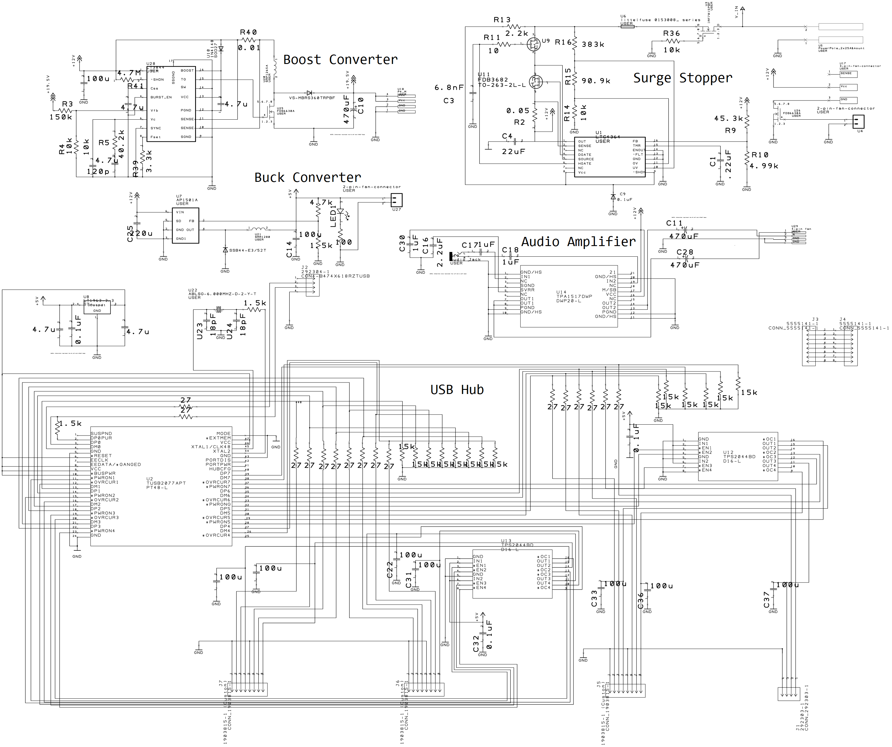

Full resolution schematic in documentation file folder (which this document should be distributed with).

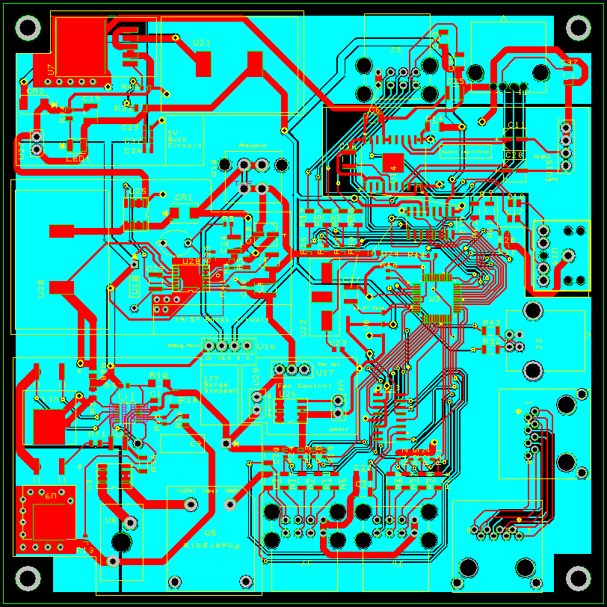

Red indicates top layer, blue indicates bottom layer. Yellow is silkscreen and some vias. Grey is some vias and pads.

This is a prototype board, not indicative of the final product. (There is at least one error).

Assembly Instructions

Board:

Solder components to board.

Associated wires:

1. Solder appropriate crimp/solder terminals to wires. (See table)
2. Odroid power connector should be assembled such that the red wire is nearer to the fuse than the black wire when the connector is plugged into the board. (Pin 1: 5V, pin 2: GND)
3. The projector power cable should be assembled such that the +19.5V wire is next to the latch on the connector, while the ground is not.
4. Audio connector should be assembled such that the left and right speaker power wires line up with the “left” and “right” annotations on the board respectively. (Pin 1: Left, Pin 2: Right, Pin3/4: GND)
5. The fan control cable should be connected so that on the motherboard end Pin 1 is power and Pin 2 is GND. On the Odroid end, follow instructions from Odroid (TO BE INCLUDED HERE)
6. The fan output cable should be wired with Pin 1 as NC, Pin 2 as power and Pin 3 as GND.
7. Other cables (USB, Audio, and Ethernet) come pre-assembled and can be plugged in as is.

Mounting:

1. Test power functionality.
2. Build cables.
3. Place board on chassis standoffs.
4. Apply screws.
5. Apply cables.

Details

Mean time between failures: NO DATA

Input Range: 11V-13.5V

Peak Inrush Current: 10.5A

Hold-Up Time: ~1ms

Transient Response: <1ms

Overvoltage Protection: 13.5V

Maximum Load Current: see outputs

Minimum Load current: just don’t leave everything unplugged, okay?

Efficiency: ~96%

Sources

Datasheets for respective components (can be found in documentation folder).

Documentation for previous version of power supply by Navid